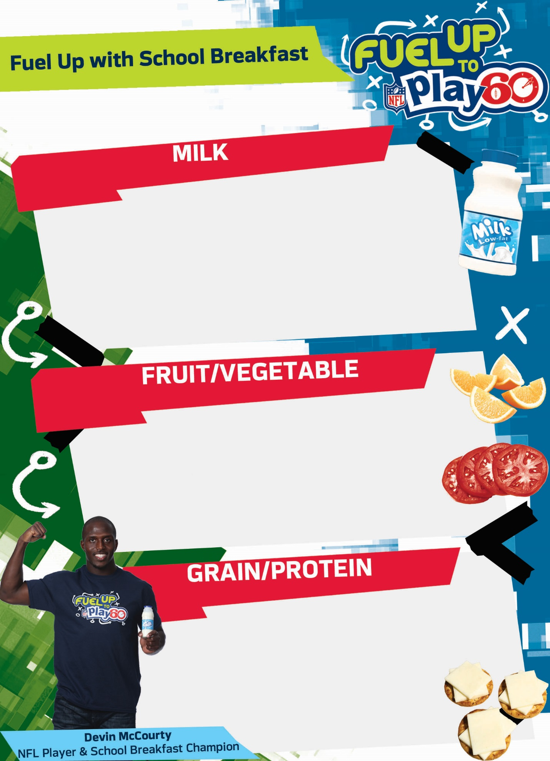\\server3\Common Files\CNFI\FUTP60\FUTP60 Style Guide, Logos & NFL Resources\1 Logos\4 NFLPA\NFLPA_for_white_bg.jpg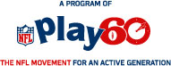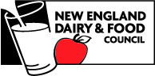

**Choose one**

**Choose up to two**

**Choose one**

**Choose at least one fruit and two other  
items…for best nutrition choose all four!**

**© 2015 New England Dairy & Food Council ®. Fuel Up is a service mark of   
National Dairy Council. © 2015 National Football League Players Incorporated.**