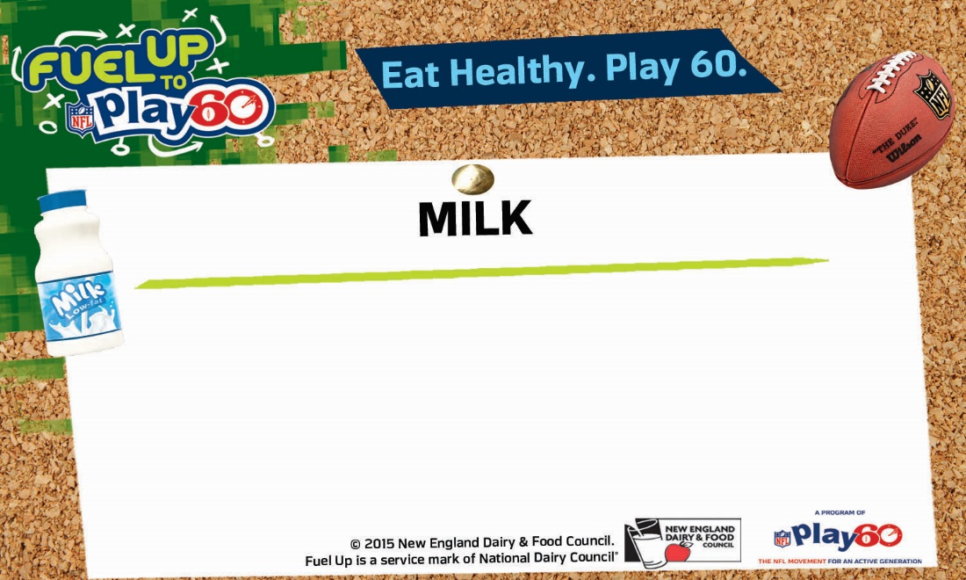

**Choose one**



**Choose one**



**Choose one**

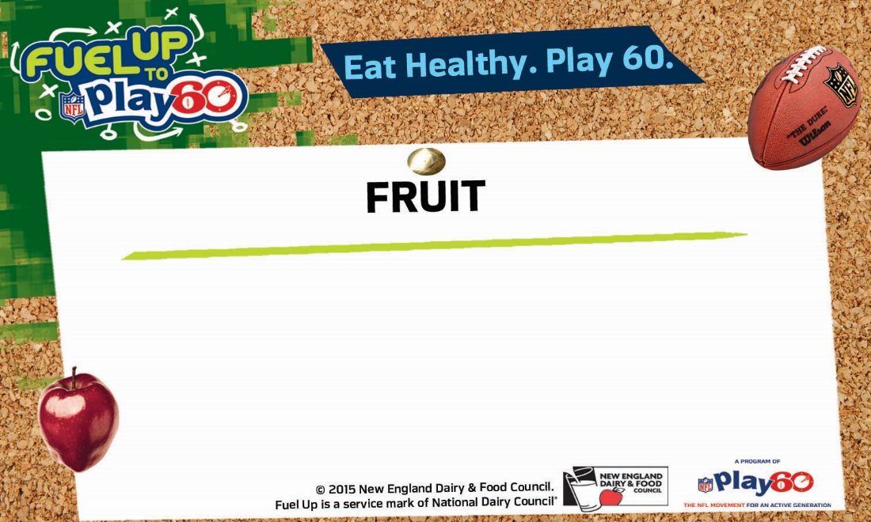

**Choose up to two**

**Choose up to two**

**Choose up to two**

**Choose one**

**Today’s Offerings**

**Choose one**

**Today’s Offerings**

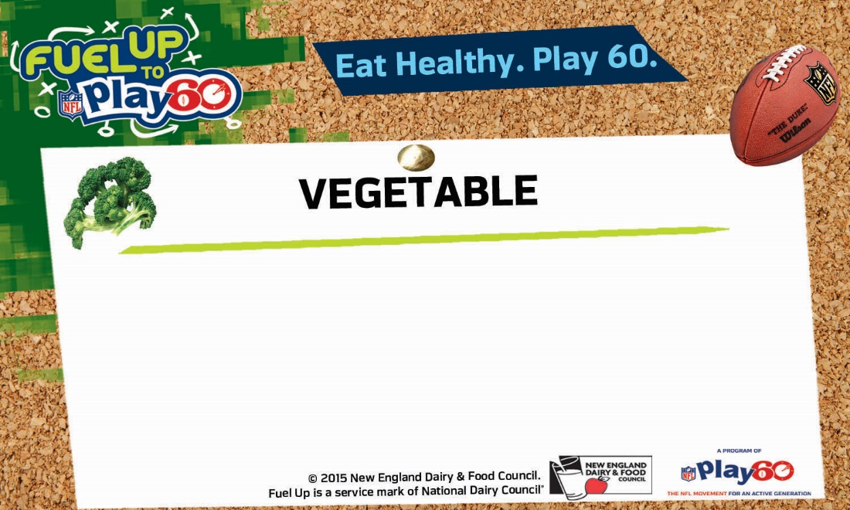

**Choose up to two**



**Choose up to two**



**Choose up to two**

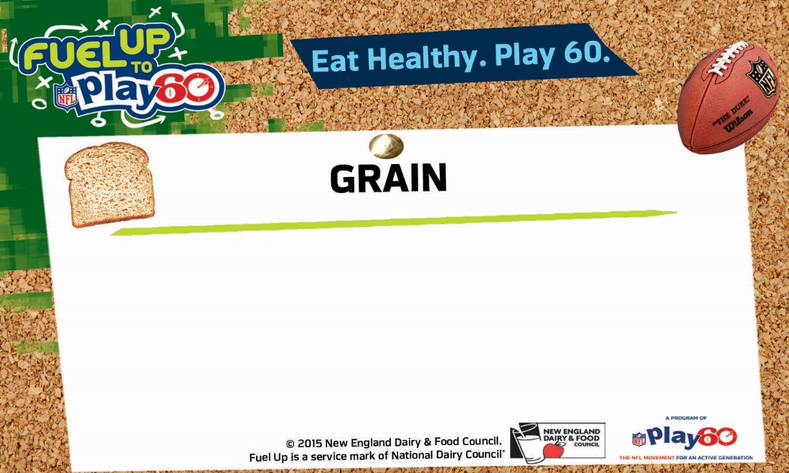

**Choose one**



**Choose one**

**Today’s Offerings**



**Choose one**

**Choose one**

**Choose one**

**Today’s Offerings**

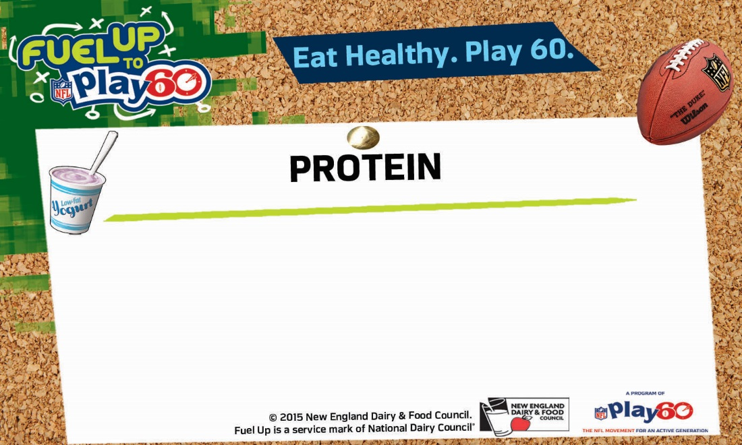

**Choose one**





**Choose one**

**Choose one**

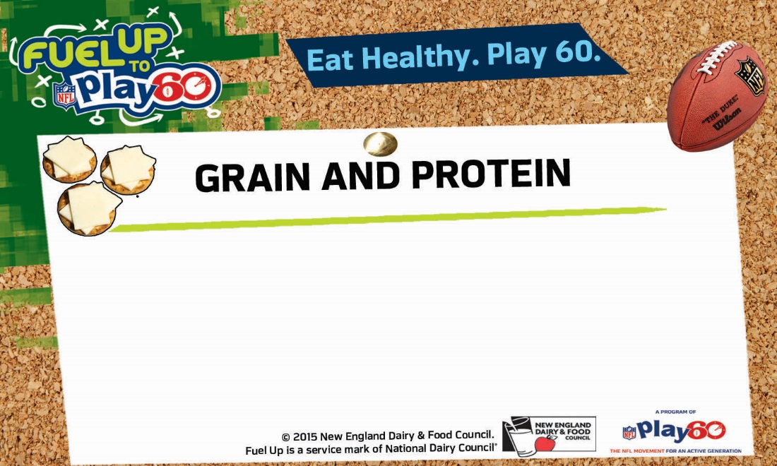

**Choose one**





**Choose one**

**Choose one**