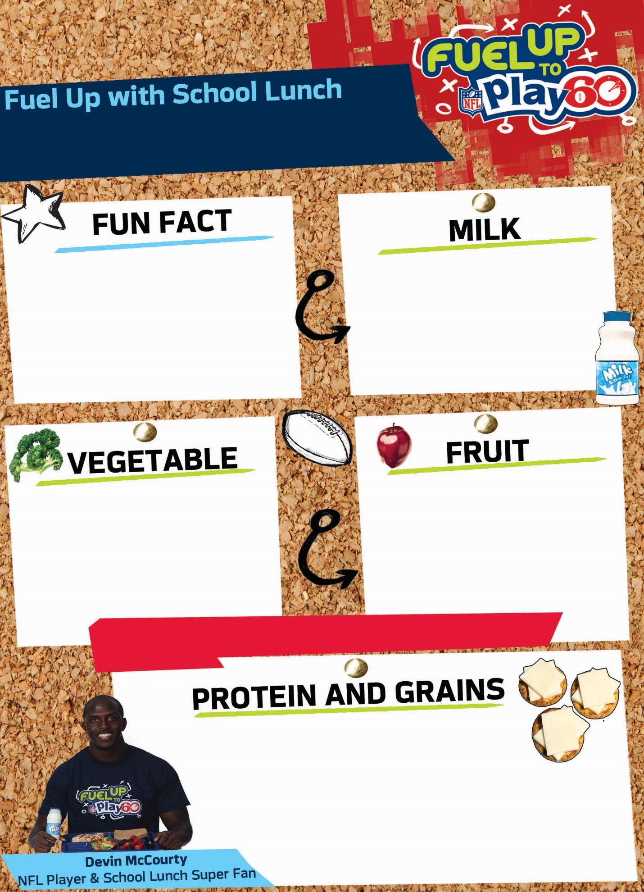

**Choose at least one fruit or vegetable and two other items…For best nutrition choose all five!**

**Choose one**

**Today’s fun fact**

**Choose up to two**

**Choose up to two**

**Choose at least one Fruit or Vegetable**

**Choose one**

\\server3\Common Files\CNFI\FUTP60\FUTP60 Style Guide, Logos & NFL Resources\1 Logos\4 NFLPA\NFLPA_for_white_bg.jpg

**© 2015 New England Dairy & Food Council ®. Fuel Up is a service mark of   
National Dairy Council. © 2015 National Football League Players Incorporated.**

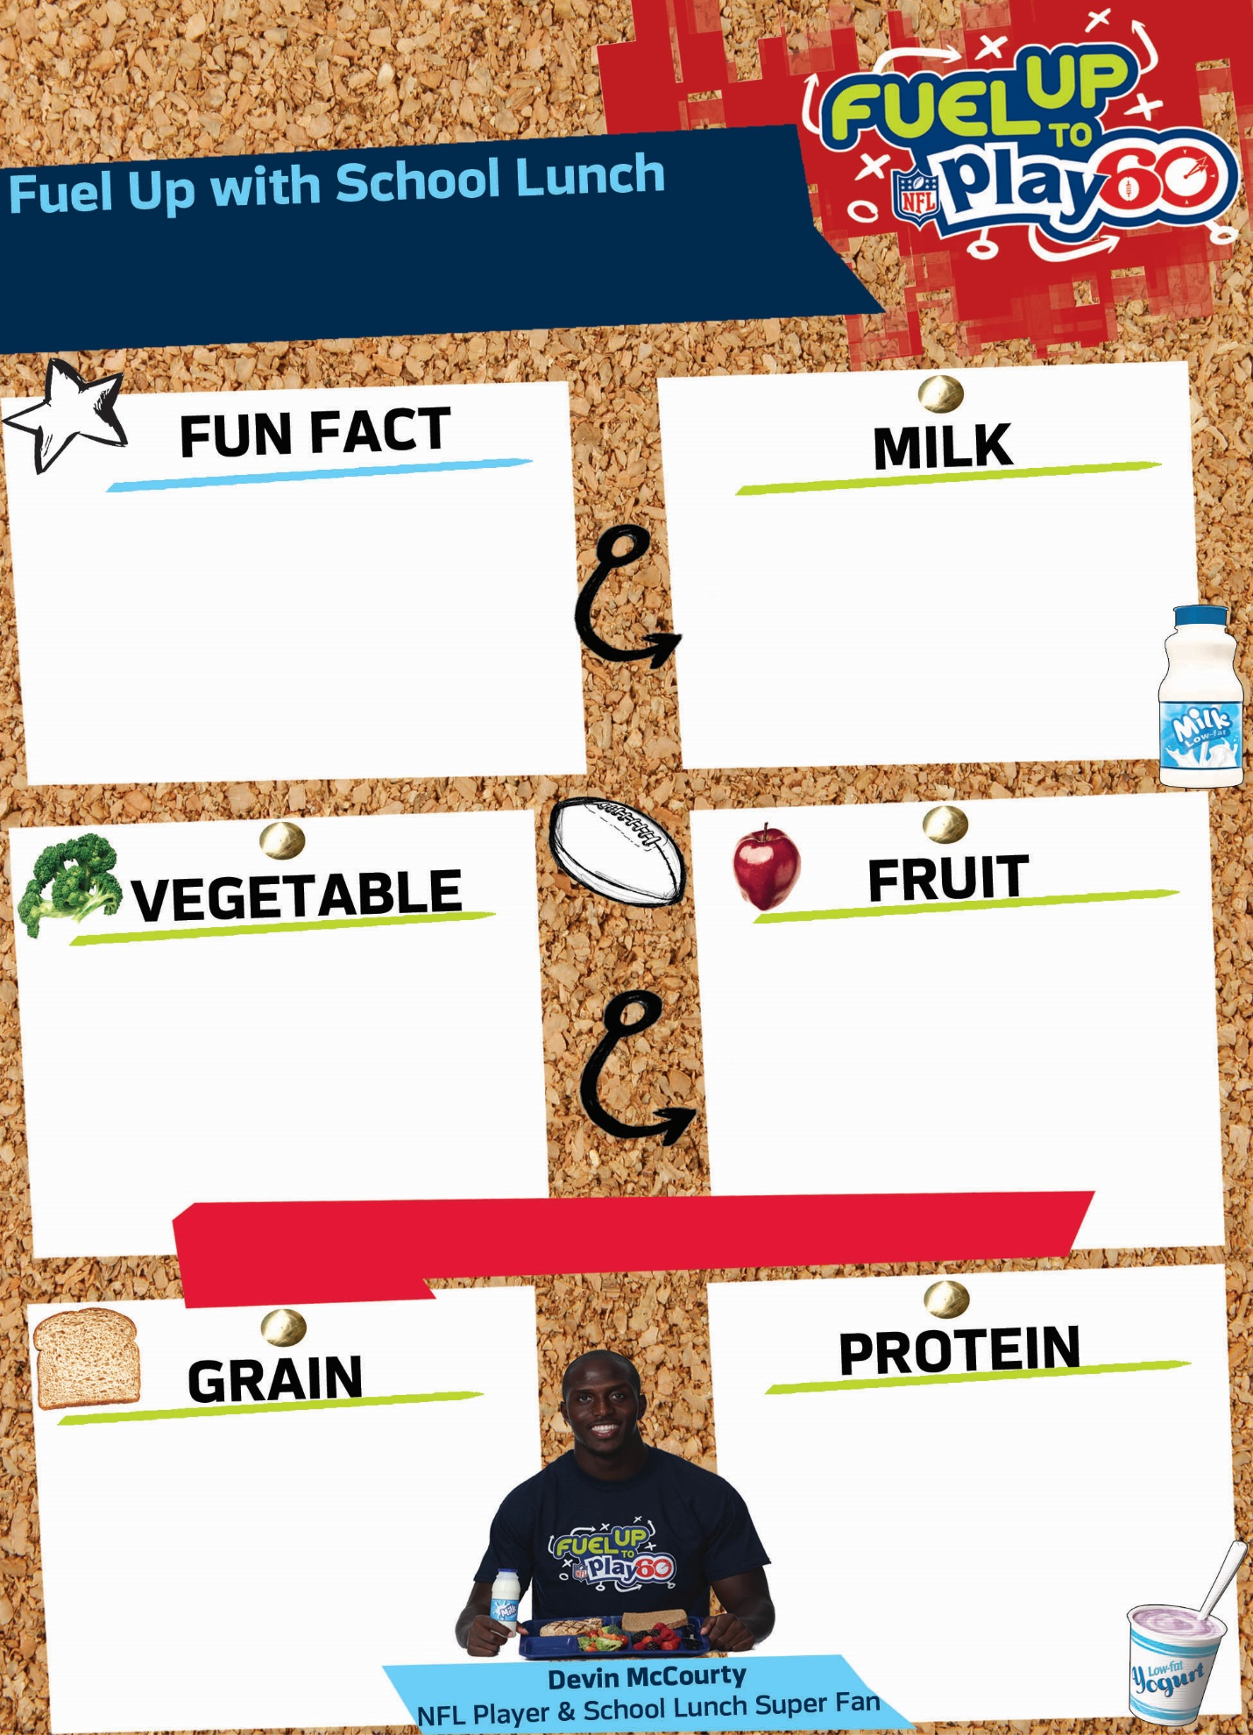\\server3\Common Files\CNFI\FUTP60\FUTP60 Style Guide, Logos & NFL Resources\1 Logos\4 NFLPA\NFLPA_for_white_bg.jpg

**Today’s fun fact**

**Choose at least one fruit or vegetable and two other items…For best nutrition choose all five!**

**Choose at least one Fruit or Vegetable**

**Choose one**

**Choose one**

**Choose up to two**

**Choose up to two**

**Choose one**

**© 2015 New England Dairy & Food Council ®. Fuel Up is a service mark of   
National Dairy Council. © 2015 National Football League Players Incorporated.**